CBOE
Book Depth Project
Requirement Specification & High Level Design Document
Version 1.1



 | 

Cognizant Technology Solutions Limited
www.cognizant.com
The information contained in this document is confidential and intended for the named recipient only. This information is property of “CBOE” and copying or disclosure by any other person is strictly prohibited. If you have received this documentation in error, please notify sender immediately.
Table of Contents
1 Introduction 5
1.1 Background 5
1.2 Purpose & Scope of this document 5
1.3 Functionality Implementation for Book Depth Project 6
1.4 Functionality Implementation for Future Phases 6
1.5 Proposed Design 6
2 System Overview 8
2.1 Current Book Depth Process Flow 8
2.2 Future Book Depth Process Flow 9
3 Requirement Analysis – Book Depth Project 10
3.1 High-level functionalities to be implemented 10
3.1.1 Market Data Buffer 10
3.1.2 Optimize Process 10
3.1.3 Market Data Bridge: Publish market data and Corba Call Quote History 10
3.1.4 Define Book Depth firm API 11
3.1.5 XBD Cache and delivery to CFN 11
3.1.6 XBD – Trader Server Recovery / Control 12
3.1.6.1 Data Feed Subscriber Outage 12
3.1.6.2 CFN or Other Network Related Outage 12
3.1.6.3 XBD Outage 13
3.1.6.4 Internal Failover / Outage Scenario Processing 13
3.1.6.5 XBD Failover 13
3.1.6.6 XBD Detects Gap Or Fails to See Ping from BC In X Seconds 13
3.1.6.7 Excessive Refresh / Duplicate Refresh Mitigation 14
3.1.6.8 BC Startup and Failover Scenarios 14
3.1.7 Event consumer connection 14
4 Implementation and Rollout changes in CBOEDirect 15
5 Assumptions, Constraints and Dependencies 15
6 Risk 15
7 Open Item and Issues 15
8 References 15
9 Appendix 15
9.1 Feature List 15
9.2 Appendix A: Glossary 18

Document Revision History

Sr. No | Description | Date | Version | Created / Modified By
1. | Template Created - Overview | 08-22-2008 | 1.0 | Manish Sharma
2. | Updated with diagrams & features | 09-05-2008 | 1.1 | Manish Sharma

Introduction

Background
The goal of the Book Depth project is to deliver an Options book depth data feed over the CBOE Financial Network (CFN) using an Industry-Standard message format such as FAST (FIX Adapted for Streaming), and to do so with no additional latency cost to the Trade Server.
The functionality to deliver the top N book levels currently exists in CBOE Direct and is used to transmit Book Depth data to One Chicago and CFE customers. However, the format of this existing feed is implemented in inefficient ASCII encoding using a proprietary CBOE message format that is non-standard. CBOE wishes to use an industry-standard message encoding such as FAST, which improves efficiency. In addition, if possible without copyright or legal issues, CBOE wishes to use the same message format for Book Depth messaging as already exists in the industry elsewhere or at least something very similar. In doing so, the adoption of the CBOE Book Depth feed by customers should be easier because little or no coding would be required by customers.
In addition, this project comes at a time when the latency of Quote processing on the Options Trade Server is a serious concern, and attempts are being made via other projects to reduce it. Since Book Depth updates on every quote, the last thing the Trade Server can afford right now is additional processing that will increase latency. Because of this, another goal has been attached to this project, which is to “do no harm” to latency while at the same time implementing the Book Depth functionality in the Trade Server. This means the existing implementation cannot be used because it is known to add latency to the main Quote processing path in the Trade Server.
Tests were conducted to determine what the current implementation would do to latency in the Trade Server. It resulted in an unacceptable increase in processing times for Options quotes. A quote step-up test was conducted on the Options Trade Engine with and without the existing Book Depth functionality turned on.
The following are the results:
Test Scenario | CAS | avg resp time
38K step up baseline test | perfcas5 | 4.7 - 6.2ms
38K step up with book depth on | perfcas5 | 6.4 - 8.9ms

This testing show that transaction times increase from 36 to 43% with the existing Book Depth functionality turned on. This is deemed to be unacceptable so it must be “payed for” by refactoring the way it works and/or by possibly refactoring completely unrelated code in the Quote processing code path in order to offset the cost.

Purpose & Scope of this document
This document presents the results of business requirements gathering and analysis for the Book Depth Project that will be available to customers. The work involved:

- Requirement Gathering and Analysis
- Documenting the business requirements in the prescribed format

It describes the rollout implications and non-functional requirements that include the performance, the time constraints and monitoring & back up/recovery.

Functionality Implementation for Book Depth Project
For the Book Depth project following functionalities will be implemented:
- MarketDataBuffer utilities and application Codecs for Quote History and Book Depth.
  - The data for following fields will be provided to the CBOE Client for Book Depth:
    - Price, Professional Volume, Customer Volume
- Replace existing Quote History path out of TradeServer with data path that combines Quote History and Book Depth into a single MarketDataBuffer and transmit to Bridge process (new process).
- New Bridge process that runs on Trade Server machine and forwards MarketDataBuffer to new MarketDataBuffer Channel, and converts QuoteHistory back to legacy format and transmits to History Server.
- New XBD – Extreme Book Depth process(es) (does not run on BC) that will collect all Book Depth updates, reconstruct the order Book, and transmit Book Depth feed to CFN network using IP Multicast and data formats that are FAST compliant.

Functionality Implementation for Future Phases
Following functionalities will be implemented in future phases:
- Add Current Market to Market data buffer containing Quote History, Book Depth data and transmit to the Bridge. Modify Trader server to no longer use CurrentMarketStruct internally and use MarketDataBuffer and a stripped down Current Market like structure that has data required only for NBBO calculation and Market Data History.
- Modify Bridge to convert Current Market data in Market data buffer to legacy CurrentMarket Struct and publish on legacy CurrentMarketChannel. This is for legacy systems still using the CurrentMarket Channel.
- Add Market Data History

Proposed Design
As part of the design, we are introducing the concept of a “market buffer”. The market buffer is essentially a sequence of bytes that can represent different pieces of information needed by the rest of the book depth processing functionality. Additionally, the market buffer can hold information needed by other CBOE process such as quote history, market data history, XTP, TPFAdapter, MDBAdapter, and CFIX. As it relates strictly to the book depth data, the market buffer will hold data that needs to be processed and sent to the recipients of the book depth data.
The market buffer will get passed to the newly introduced “bridge” process. The responsibility of the bridge process will be to deliver the data contained in the market buffer to various systems in the format they currently expect (more details related to this will be presented later in this document).
The bridge process will then forward the market buffer message to the newly introduced “XBD” process. The responsibility of the XBD will be to take the updates contained in the market buffer and do the following:
- keep track of the current book by product
- format book depth updates to be sent to the CFN
- multicast book depth updates to the CFN
- allow for data recovery from the BCs
- allow for book depth data snapshots to be sent to the CFN
The XBD will be developed in a way in which it can be run in either a single Master/Slave cluster or multiple cluster distributed by multicast groups. There would be bridge process per BC.
The book refresh and book snapshots sent to the CFN will be sent via multicast. Additionally, the data will be formatted according to the FAST FIX specification. Both the multicast and FAST FIX have rooted themselves as the emerging standard for the delivery of book depth information.
In order to facilitate our help desk and operation areas, the book depth data will be retrievable via the SAGUI as its currently working. This is implemented as a query-response mechanism without dynamic updates for Trader GUI and SAGUI as its currently working.
The end users receiving the data from the CFN will see the following:
- Individual book updates by product
- Periodic full book updates (to N levels) for each product

Book Depth Processing Flow
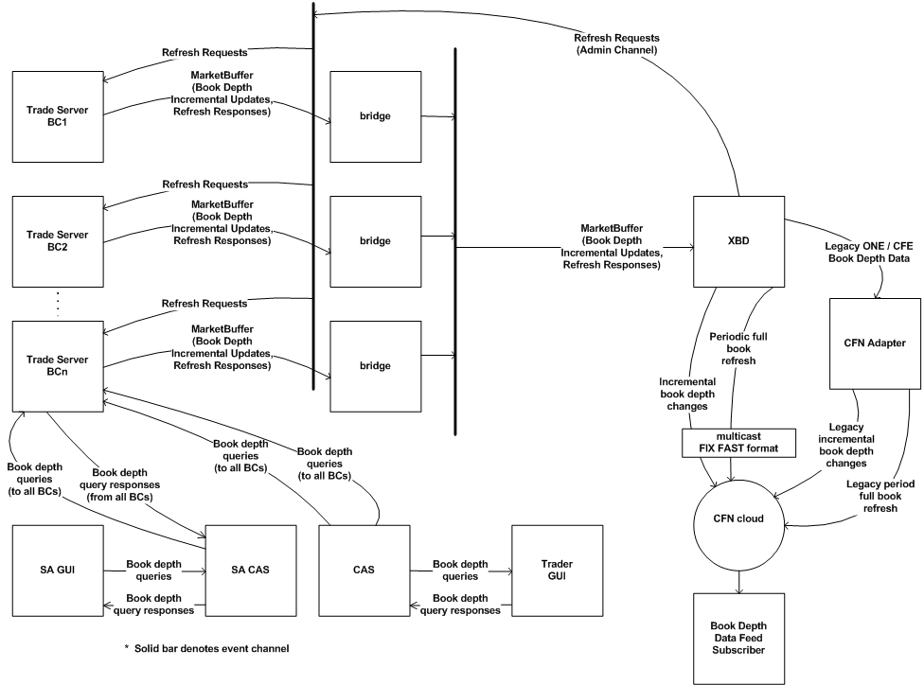
The following diagram shows the high level design of the book depth message processing:

System Overview

Current Book Depth Process Flow
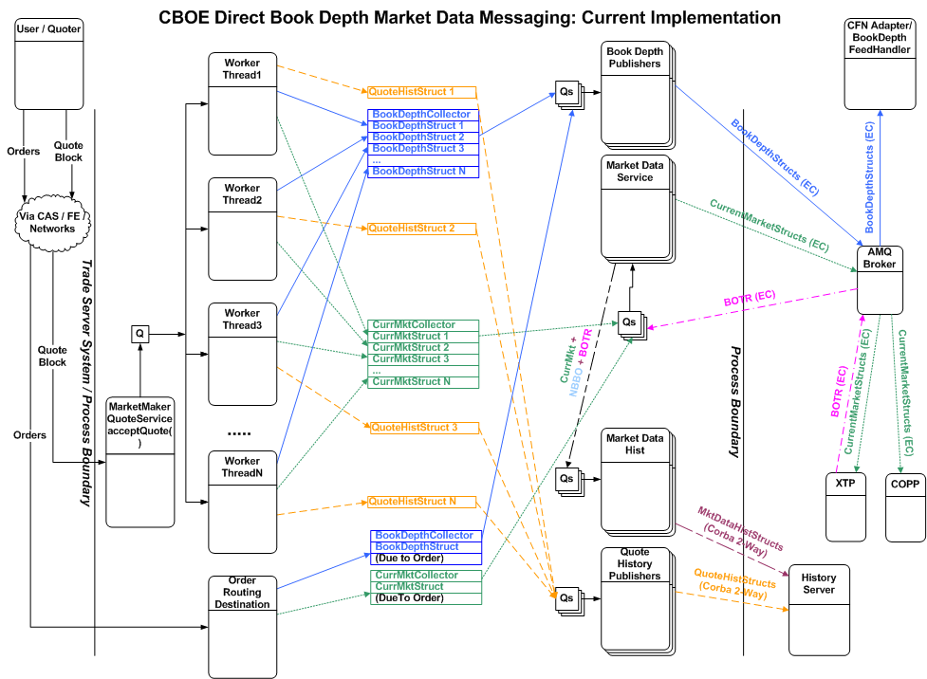
The diagram below shows the data flow of Book related data in the Trade Server.

Future Book Depth Process Flow
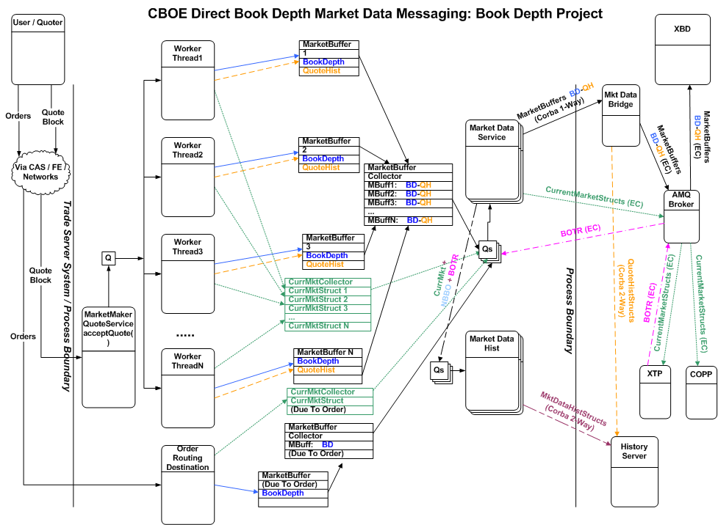
The diagram below shows the new data flow of Book related data in the Trade Server

Requirement Analysis – Book Depth Project

High-level functionalities to be implemented

Market Data Buffer
To consolidate different kind of data to be published into a single entity that occupies contiguous memory, a logical choice is to use a byte array and store the data in serialized format.
The idea for the market data buffer is relatively simple. For every set of correlated results of a transaction, create one MarketDataBuffer. In the case of an individual quote update, its corresponding artifacts, Quote History, Book Depth update, and Current Market update would all be stored in this one buffer. As part of the broader transaction that represents an entire block of quotes, a collector that ties together the individual MarketDataBuffers together would also be built. Each quote update and it’s artifacts occupy one buffer and act as one unit of delivery to a downstream process.
One problem with passing around encoded data in serialized format is to insure that knowledge of how the bytes are physically stored and the order of the fields in the encoded data are strictly limited to a single or very small number of Java Classes, and to enforce some kind of encapsulation. In addition, as knowledge of how to better compact data and better encode it in the future comes about, some kind of upgrade path provision for adding new fields, supporting new types of encoding, etc. must be supported.
To facilitate encapsulation of how primitive types are encoded and decoded a “Codec” (coder / decoder) is contemplated for each kind of primitive type, and where necessary, for small business-level objects (such as prices and other small commonly used structures).
Field level primitive Codecs are assembled into groups (like a struct) or sequences (like an array) and ultimately into a “Message Codec” which represents some business-level structure “template”. Access to a Message Codec is controlled by the business-level implementation of that Message Codec. The access is similar to the way one would access IDL-generated Java structs, except the fields are not public and can only be accessed via methods, which makes it better encapsulated. Further, the business-level Message Codec is in control of what fields can be modified and the interface in which they modify them. If necessary, validation could be done to insure invalid values are not allowed, and all kinds of things are possible since the business Message Codec is a Java object that is written and is not generated code like IDL.
The Message Codec knows how to encode itself into and decode itself from a MarketDataBuffer. Access to the MarketDataBuffer will be controlled so that only Message Codecs may access it’s physical storage directly.
NOTE: Please refer to Appendix - Feature list in section 9.1 for further detail.

Optimization Process
TBD

Market Data Bridge: Publish market data and Corba Call Quote History
The Market Data Bridge is a new process. Its job is to take MarketDataBuffer data from the Trade Server and distribute it to the necessary downstream entities, in some cases converting it to legacy structures.
Market Data Buffer data comes into the process (as bytes). It is re-constructed into MarketDataBuffers, and enqueued to N sets of Threads, possibly using different dispersion mechanisms (by class vs product for example) to exploit better performance for the different sets of Threads as needed.
One set of Threads will re-block the MarketDataBuffer data into a block for transmission to the MarketBuffer Channel. Another Thread will convert the Quote History data contained in the MarketDataBuffer to a legacy QuoteHistoryStruct. This will then be transmitted to the History Server for recording to Quote History.
NOTE: Please refer to Appendix - Feature list in section 9.1 for further detail.
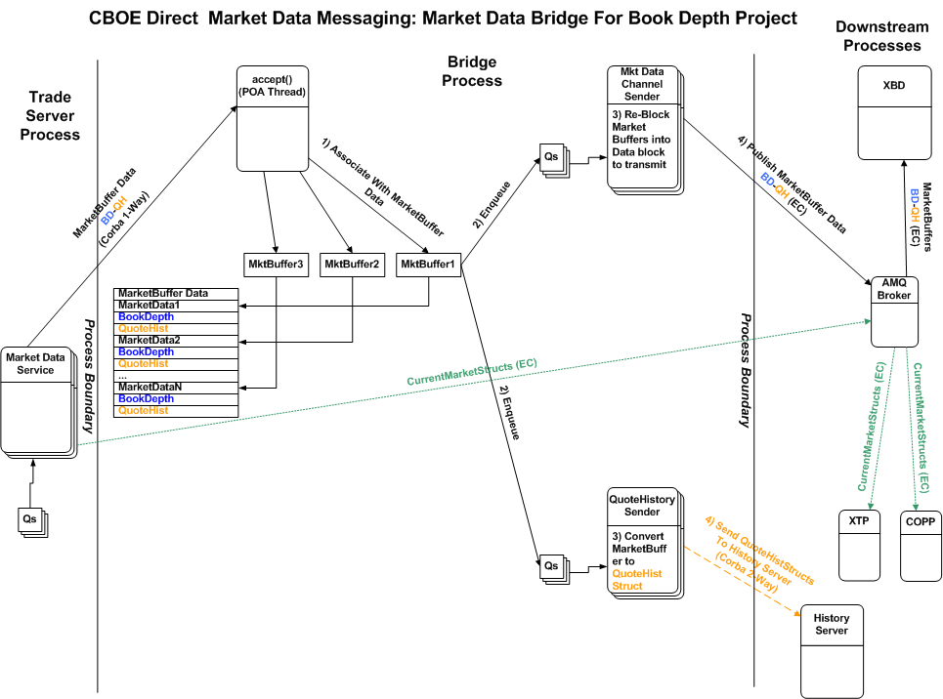
Please find the diagram for the process structure of Market Data Bridge below:

Define Book Depth firm API
Pending to be discussed.

XBD Cache and delivery to CFN
The XBD is a new process. It is contemplated it will be based on XTP software because it seems like a natural fit and many of the building blocks required to implement it are available in XTP.
The XBD will take Refresh and incremental Book Depth updates from each BC and store it in a Cache, which will be a reconstruction of the Order Book’s price levels, but without the individual quotes and orders.
When a book entry is updated, the XBD will figure out what levels of the book changed and will fire an update event. Attached to that update event will be code that knows the format of the data required for the data feed to be transmitted out the CFN network. That data will be queued to another Thread that will then attach a sequence number and encode the data into FAST format and transmit it out a Multicast group to Data Feed Subscribers.
NOTE: Please refer to Appendix - Feature list in section 9.1 for further detail.
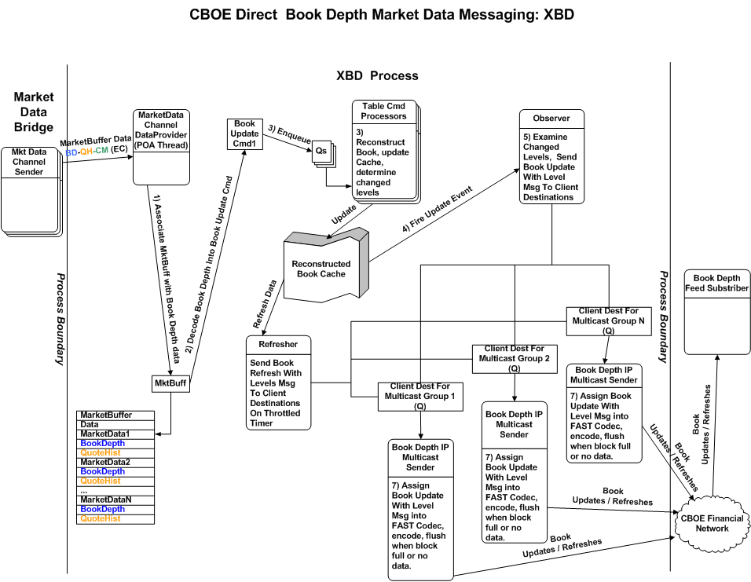
Please find the diagram for the process structure of XBD below:

XBD – Trader Server Recovery / Control

Data Feed Subscriber Outage
In the event a Data Feed Subcriber goes down and comes back up, they should zero-out their book entries for all products or mark them unusable, etc. The Subscriber must wait for a Refresh message for a particular product before using it for trading. Incremental messages for the same product may appear, but they should be discarded until a Refresh message for that product appears.

CFN or Other Network Related Outage
The Subscriber to the Book Depth Feed will get 2 duplicate sets of Book Depth feeds over different IP Multicast groups and ports and over different physical networks. In order to handle single-network outages between CBOE and the Subscriber, the Subscriber should read both sets of feeds simultaneously and choose which message to read using the sequence number. If one of the redundant feeds does not have a particular message due to some kind of network problem, then that message should appear on the other network (except in rare dual network failure scenarios or if networks are not designed properly at the customer site and really go through a single source, etc.).If there is no problem and both identical messages are read, the Subscriber must choose one and discard the other.
In the event of a dual-network outage, the Subscriber should either detect that there is no data for some small period of time (a few seconds) or a sequence gap should be detected. In either case, all products that are transmitted over the problematic Multicast Feed must be considered stale and made invalid. The Subscriber must then wait for a Refresh message for each product before it may be used again.

XBD Outage
In the event of a XBD outage, the backup XBD will take over processing, however, this failover may take a few seconds. During the failover time period, the Subscriber should detect no data arriving for some number of seconds, which should trigger the “idle data feed” scenario described above in CFN or Other Network Related Outage above.
When the backup XBD takes over, it will issue a new sequence number that is higher than the last known sequence number and this too should trigger the Subscriber’s failover scenario described above because there will appear to be a sequence gap on the Subscriber’s side.

Internal Failover / Outage Scenario Processing
Between the BC and the XBD, there will be a “Ping” or “heartbeat” message that is transmitted every few seconds. In addition, all messages between BC and XBD are sequenced to insure nothing is dropped and if something is dropped, that it can be detected. Below are the outage scenarios and actions:

XBD Failover
The XBD will have a primary and a backup (Master/Slave). Both will receive Book Depth updates and will keep a Cache that reconstructs the Book. They will operate independently with regard to internal outage scenarios that follow.
However, in the event of a failover between the primary / backup, a failover will do the following:
- Disable the outbound feeds on one XBD
- Enable the outbound feeds on the backup XBD
The act of enabling the outbound feeds activates the following processing:
- Walk the entire book and mark it as “transmitRefreshOnNextUpdate”. If an incremental update is seen when this flag is set, it causes the update to send a Refresh to the Data Feed Subscriber. Once this occurs, this flag is then turned off.
- Make a second, throttled walk through the entire book. Because this is due to a failover, however, this Refresh might be throttled at a faster rate than the “standard” Refresh that continuously runs in the background. For each record with the flag transmitRefreshOnNextUpdate still on, transmit a Refresh message to the Data Feed Subscriber and turn off the flag.
- After this initial refresh is completed, the normal speed continuous refresh is transmitted.
As described above, Data Feed Subscribers should detect this failover by either lack of data or by the sequence gap that will occur when the backup becomes the primary. Data Feed Subscribers should trigger their recovery mode and wait for the next Refresh for any given product.

XBD Detects Gap Or Fails to See Ping from BC In X Seconds
In this scenario, there is a gap in the sequence numbers coming from the BC, or there is the absence of data from a particular BC in some number of seconds. These scenarios are identical with respect to the XBD viewpoint, and it does the following:
- Walk the Book Cache for those products that are updated via the BC for which the outage was detected.
- For all products in the Book Cache for that BC, zero out the Book entry data and transmit a Refresh message to all Data Feed Subscribers containing zero book entries for that product. This indicates that the Book for that product is no longer valid and must not be used.
- Mark the zeroed-out book entries for each product so that a full Refresh is required before incremental updates will be accepted again. When this flag is on, any incremental update for that product will be discarded.
- Wait for a Ping from the BC for which the sequence gap or lack of data was detected. AFTER the ping arrives, request a Refresh from that BC.
Once a Refresh is seen for a particular product, it’s book is updated, the “full-Refresh-Required” flag is turned off, and a Refresh is sent to all Data Feed Subscribers. This is how things get back to normal.

Excessive Refresh / Duplicate Refresh Mitigation
There should be some kind of logic to mitigate repeated Refresh requests from bombarding the BC, and there should be some logic in the BC to permit only one Refresh to be active at a given time. In addition, in the BC the Refresh could be throttled so that the Refresh processing does not interfere with normal processing. The Throttle could be set so that the refresh lasts some period of time or transmits no more than X number of messages per second. For example, a BC with 15,000 products at 500 msgs / second would take 30 seconds to complete the Refresh.
To prevent repeated rapid refresh requests in the event of a frequent sequence gap scenario, the XBD should make Refresh requests only every so often, perhaps tens of seconds. If a gap or outage is detected and a request is outstanding, it should avoid repeated frequent duplicate Refresh requests until some time period has passed. Though not strictly required, but if it is possible with relative little difficulty, it would be useful if the XBD could also detect if it is in a situation where sequence number gaps are repeating frequently and it is frequently requesting refreshes. This should be an extremely rare situation, however, so it may not be worth the effort to detect. Not much could be done about it anyway that isn’t addressed by mitigating the frequency of the Refresh requests from the BC.
To prevent impacting the BC excessively when a Refresh is requested, the BC should know when it is already in the middle of a Refresh. If another Refresh request comes in, the BC may do one of two things depending on which is easier or more logical to implement:
- Abandon the current Refresh and start over.
- Implement the Refresh as a circular traversal where the begin and end-points may be modified during mid-traversal. If in the middle of a Refresh another Refresh is received, reset the start to be the next product and the end to be the product for which a Refresh was just transmitted.
In addition, the Refresh processing in the BC should be throttled vs run at full speed to minimize impact.

BC Startup and Failover Scenarios
At BC startup and in a BC failover scenario, there is a step where the BC rebuilds it’s order book. When this occurs, the BC should transmit a Ping message to the XBD to indicate it is ready to accept a Refresh request.
If the XBD is active, it should be in a state where it thinks the BC is down and it should be waiting for the Ping from the BC to trigger its request for a Refresh.

Event consumer connection
Pending to be discussed

Implementation and Rollout changes in CBOEDirect
Changes will be made for:
- BC
- Bridge
- XBD

Assumptions, Constraints and Dependencies

TBD

Risk
TBD

Open Item and Issues
TBD

References
TBD

Appendix

Feature List
 | Book depth project | Start Date: | 2/11/2008
Line # | Feature | Feature Owner | Date Added | Initial Estimate (Days)
 | Trade Server quote processing enhancements and recovery
2 | requirements and analysis | Peterson | 5/1/2008 | 5
3 | look at CFN adapter and XTP as a basis for book depth adapter | Peterson | 4/23/2008 | 3
4 | development environment setup | Peterson | 4/23/2008 | 5
5 | development environment installation | Peterson | 4/23/2008 | 5
6 | overall book depth adapter design | Peterson | 4/23/2008 | 10
7 | setup marketDataBuffer class | Peterson | 8/25/2008 | 6
8 | develop abstract codec | Peterson | 8/25/2008 | 5
9 | develop int codec | Peterson | 8/25/2008 | 4
10 | develop long codec | Peterson | 8/25/2008 | 3
11 | develop short codec | Peterson | 8/25/2008 | 3
12 | develop byte codec | Peterson | 8/25/2008 | 3
13 | develop string codec | Peterson | 8/25/2008 | 5
14 | develop price codec | Peterson | 8/25/2008 | 3
15 | develop group codec | Peterson | 8/25/2008 | 3
16 | develop sequence codec | Peterson | 8/25/2008 | 4
17 | integrate marketDataBuffer class into TTE | Peterson | 8/26/2008 | 6
18 | instantiate quote history codec | Peterson | 8/25/2008 | 5
19 | instantiate book depth codec | Peterson | 8/25/2008 | 5
20 | instantiate ping codec | Peterson | 9/2/2008 | 2
21 | identify location of book depth allocation | Peterson | 8/25/2008 | 3
22 | identify use of book depth allocation | Peterson | 8/25/2008 | 2
23 | identify location of quote history allocation | Peterson | 8/25/2008 | 3
24 | identify use of quote history allocation | Peterson | 8/25/2008 | 2
25 | marketDataBuffer instance management (get, set, flush) | Peterson | 8/25/2008 | 10
26 | fill marketDataBuffer | Peterson | 8/25/2008 | 10
27 | send marketDataBuffer | Peterson | 8/25/2008 | 1
28 | instantiate Collector |  | 8/26/2008 | 5
29 | add marketDataBuffer to collector |  | 8/26/2008 | 1
30 | enque to market data buffer holder data service |  | 8/26/2008 | 3
31 | associate Collector with transaction |  | 8/26/2008 | 15
32 | deque market buffers |  | 8/26/2008 | 1
33 | identify market buffers |  | 8/26/2008 | 2
34 | publish market buffers |  | 8/26/2008 | 1
35 | optimize publish of market buffer |  | 8/26/2008 | 10
36 | IDL development |  | 8/26/2008 | 1
37 | create market data bridge proxy |  | 8/26/2008 | 5
38 | add instrumentation to market buffer operations |  | 8/26/2008 | 2
39 | ITG test script updates for regression testing |  | 8/26/2008 | 5
40 | ITG regression testing to verify trade server changes only impact quote history and book depth | Peterson | 8/26/2008 | 5
41 | iteration 1 quote path optimization | Peterson | 8/26/2008 | 15
42 | iteration 1 ITG quote path optimization testing | Peterson | 8/26/2008 | 5
43 | iteration 2 quote path optimization | Peterson | 8/26/2008 | 15
44 | iteration 2 ITG quote path optimization testing | Peterson | 8/26/2008 | 5
45 | iteration 3 quote path optimization | Peterson | 8/26/2008 | 15
46 | iteration 3 ITG quote path optimization testing | Peterson | 8/26/2008 | 5
47 | iteration 4 quote path optimization | Peterson | 8/26/2008 | 15
48 | iteration 4 ITG quote path optimization testing | Peterson | 8/26/2008 | 5
49 | send ping | Peterson | 9/2/2008 | 3
50 | accept refresh request | Peterson | 9/2/2008 | 3
51 | IDL changes for recovery | Peterson | 9/2/2008 | 1
52 | send refresh message | Peterson | 9/2/2008 | 12
 | Bridge
54 | accept market buffer | Peterson | 8/27/2008 | 5
55 | deblock individual market buffer | Peterson | 8/27/2008 | 1
56 | build hearder | Peterson | 8/27/2008 | 1
57 | route to Q | Peterson | 8/27/2008 | 5
58 | publish market buffers | Peterson | 8/27/2008 | 5
59 | IDL development | Peterson | 8/27/2008 | 2
60 | create book depth event channel | Peterson | 8/27/2008 | 1
61 | publish quote history | Peterson | 8/27/2008 | 10
62 | documentation | Peterson | 8/27/2008 | 5
63 | configure development process | Peterson | 8/27/2008 | 10
64 | configure prod environment | Peterson | 8/27/2008 | 1
65 | modify/create scripts | Peterson | 8/27/2008 | 10
66 | modify Patrol environment | Peterson | 8/27/2008 | 1
67 | modify CTL-M schedule | Peterson | 8/27/2008 | 1
68 | ITG regression testing to verify trade server changes only impact quote history and book depth | Peterson | 8/27/2008 | 5
69 | develop book depther process stub (NULL impl) | Peterson | 8/27/2008 | 2
70 | perform bridge failover | Peterson | 8/27/2008 | 5
 | XBD
72 | configure XBD process | Peterson | 8/29/2008 | 5
73 | analyze reuse of XTP | Peterson | 8/29/2008 | 10
74 | decode market data buffer | Peterson | 8/29/2008 | 1
75 | build database command | Peterson | 8/29/2008 | 1
76 | attach to CFN event channel | Peterson | 8/29/2008 | 3
77 | layout internal cache | Peterson | 8/29/2008 | 10
78 | execute internal cache update command | Peterson | 8/29/2008 | 10
79 | implement FAST book depth observer | Peterson | 8/29/2008 | 3
80 | design outbound delta/refresh | Peterson | 8/29/2008 | 9
81 | implement FAST book depth block handler | Peterson | 8/29/2008 | 5
82 | modify XTP FAST implementation | Peterson | 8/29/2008 | 50
83 | implement new FAST encoder | Lynch | 8/29/2008 | 99
84 | configure multicast output | Peterson | 8/29/2008 | 3
85 | send FAST multicast | Peterson | 8/29/2008 | 5
86 | implement FAST book depth client | Peterson | 8/29/2008 | 5
87 | documentation | Peterson | 8/29/2008 | 5
88 | implement legacy book depth observer | Peterson | 8/29/2008 | 4
89 | implement legacy event channel sender | Peterson | 8/29/2008 | 7
90 | implement legacy book depth client | Peterson | 8/29/2008 | 7
91 | ITG test scripts | Peterson | 8/29/2008 | 15
92 | ITG regression testing | Peterson | 8/29/2008 | 10
93 | log book depth data for replay | Peterson | 8/29/2008 | 4
94 | replay book depth | Peterson | 8/29/2008 | 10
95 | modify/create scripts | Peterson | 8/29/2008 | 10
96 | setup production environment | Peterson | 8/29/2008 | 5
97 | accept ping | Peterson | 9/2/2008 | 1
98 | detect sequence number gap | Peterson | 9/2/2008 | 4
99 | detect ping loss | Peterson | 9/2/2008 | 4
100 | send refresh request to trade server | Peterson | 9/2/2008 | 5
101 | AR command to send refresh request | Peterson | 9/2/2008 | 1
102 | clear book entries for BC | Peterson | 9/2/2008 | 2
103 | send refresh events to CFN | Peterson | 9/2/2008 | 2
104 | log reader for testing | Peterson | 9/2/2008 | 5
105 | CFN test client | Peterson | 9/2/2008 | 5

Appendix A: Glossary
Term | Description
TBD

